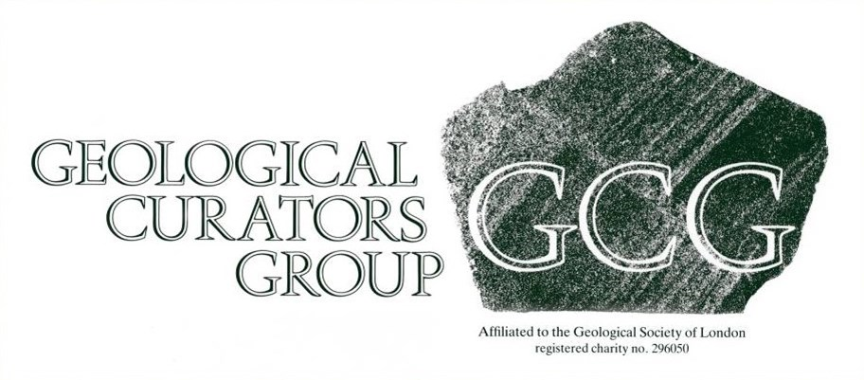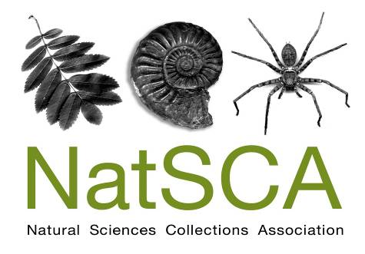

Hazards in museum geological collections – the practicalities

**A joint NatSCA and GCG workshop**

Friday, October 17, 2014 - 10:00 to 17:00

Oxford University Museum of Natural History

Please complete this booking form and send to Holly Morgenroth address below.

Please keep a copy of your form for reference.

**DELEGATE DETAILS:**

|  |  |
| --- | --- |
| **Name(s):** |  |
| **Organisation:** |  |
| **Address:** |  |
| **E-mail:** |  |
| **Tel:** |  |

WORKSHOP COSTS:

|  |  |  |  |
| --- | --- | --- | --- |
|  | Cost per delegate | Number of delegates | Total cost |
| Member* | £28 |  |  |
| Non-member** | £41 |  |  |
|  |  | TOTAL |  |

* Please note that two member rate places are permitted at each workshop for institutional members.

** For just £15 you can become a NatSCA member and enjoy member rate places at our conferences and workshops as well as receiving our journal twice a year. Contact Maggie Reilly for information [maggie.reilly@glasgow.ac.uk](mailto:maggie.reilly@glasgow.ac.uk)

|  |  |
| --- | --- |
| A light lunch will be provided. Please note any special dietary requirements: |  |

Please complete the payment section of the form as FULLY and ACCURATELY as possible

Please answer ‘yes’ where appropriate.

|  |  |
| --- | --- |
| Delegate Names: |  |

Who will be paying for this course?

|  |  |
| --- | --- |
| Myself |  |
| My institution |  |
| Don’t know yet |  |

|  |  |
| --- | --- |
| I will be paying | |
| I have enclosed a cheque with this form |  |
| I have already sent payment by bank transfer |  |
| Please send an invoice for the amount above |  |
| Please issue a receipt |  |

|  |  |
| --- | --- |
| Institutional Payment | |
| My institution will pay by cheque or bank transfer |  |
| Please send an invoice for the amount above |  |
| Please issue a receipt |  |
|  | |
| *Name of institution paying |  |
| *Invoice made out to |  |
| *Invoice sent by post or email to |  |

*e.g. for myself at RAMM I would complete as:

Exeter City Council

Exeter City Council, Civic Centre, Paris Street, Exeter, Devon, EX1 1JN

Holly.Morgenroth@exeter.gov.uk

Cheques

Please make cheques payable to the ‘Natural Sciences Collections Association’

##### BACS payments

##### Please quote the invoice number with all transfers. If an invoice is yet to be issued the delegate’s name must be quoted.

Bank – HSBC

Branch – Hereford High Town Branch, 35, High Town, Hereford, HR1 2AQ

Sort Code – 40-24-11

Account no. – 91645722

Account name – Natural Sciences Collections Association

**Please send booking forms and payments to:**

**Holly Morgenroth:** 3 Abbey Road, Exeter, Devon, EX4 7BG. [holly.morgenroth@exeter.gov.uk](mailto:holly.morgenroth@exeter.gov.uk)