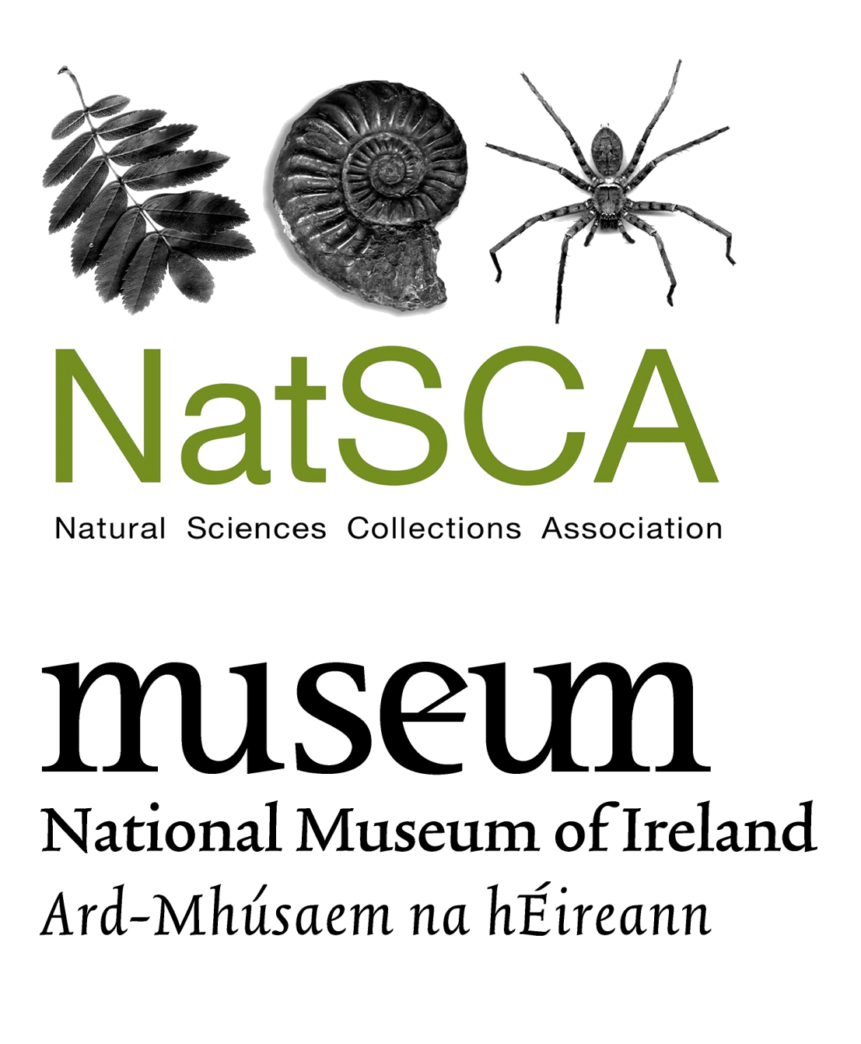

Dead Interesting: Secrets of Collections Success

Collections | Engagement | Museums & Tech

NatSCA AGM & Conference,
Dublin 1–3 May 2019
National Museum of Ireland - Collins Barracks

Please see the Eventbrite listing for full details of the conference meal, store tours, refund policy etc.

BOOKING FORM

CONFERENCE COSTS:

Early bird booking (by March 22nd 2019): Two day cost: NatSCA members £90, non-member £125

One day cost: NatSCA members £50, non-member £70

From March 22nd 2019: Two day cost: NatSCA members £120, non-member £140

One day cost: NatSCA members £65, non-member £85

Speakers: The day you speak is free of charge. Additional days charged at above one day costs.

Conference meal at Market Bar: £22 (includes service charge)

(For menu see: marketbar.ie/set-menu

Limited spaces, so book early!)

* Please note that two member-rate places are permitted at the conference for institutional members.

** For just £20 you can become a NatSCA member and enjoy member rate places at our conferences and workshops as well as receiving our annual journal. Contact membership@natsca.org for information, or join online at http://natsca.org/membership

Please send your completed form by email to treasurer@natsca.org. If you are paying by cheque please send your form and payment to the treasurer at home not work – 3 Abbey Road, Exeter, EX4 7BG.

BOOKING DETAILS

If using this form for multiple delegates, please include details for each delegate.

Name:

Organisation:

E-mail:

Access requirements?

Dietary requirements?
Twitter username  (will appear on delegate badge) | @

I give permission for my name, organisation and email to appear on the delegate list YES / NO

SPEAKERS ONLY

I am speaking on: THURSDAY / FIRDAY

I am attending: JUST THE DAY I’M SPEAKING / BOTH DAYS

 | Both days |  | Thursday only |  | Friday only |  | Total
 | Ticket price | No of delegates | Ticket price | No of delegates | Ticket price | No of delegates
EARLYBIRD Booked by 22nd March 2019
EARLYBIRD Member* | £90 |  | £50 |  | £50
EARLYBIRD Non-member** | £125 |  | £70 |  | £70
Booked on or after 22nd March 2019
Member* | £120 |  | £65 |  | £65
Non-member** | £140 |  | £85 |  | £85
Speakers only
The day you speak is free | N/A | N/A | £0 |  | £0
Conference meal
 |  |  | £22
 |  |  |  |  |  | TOTAL
Please note that NatSCA is not VAT registered.

TOURS
If you would like to attend tours please book a time, location and date below. We will be organising a coach for the Wednesday tours, with capacity for 45 people. The coach will pick-up from the airport at several times between 10:30am and 2:15pm (full details of location and time once bookings are confirmed):

Date | Time | Location of tour | Delegate names | Seat on coach for tour?
Weds May 1 | 1pm | NMI Collections Resource Centre
Weds May 1 | 3pm | National Botanic Gardens
Fri May 3 | 2pm to  5pm | NMI Natural History Museum and Trinity College Zoology Museum

PAYMENT

I will be paying
I have enclosed a cheque with this form
I have already sent payment by bank transfer
Please send me an invoice for the amount above

My institution will be paying
My institution will pay by cheque or bank transfer
Please send an invoice for the amount above
*Name of institution paying
*Invoice made out to
*Invoice sent by post or email to
PURCHASE ORDER NUMBER
*e.g. for myself at RAMM I would complete as:
Exeter City Council
Exeter City Council, Civic Centre, Paris Street, Exeter, Devon, EX1 1JN
Holly.Morgenroth@exeter.gov.uk

WAYS TO PAY

Online Payment

You can book and pay for this event online through Eventbrite by following this link: https://www.eventbrite.co.uk/e/dead-interesting-secrets-of-collections-success-2019-conference-agm-tickets-57711821612

Cheques

Please make cheques payable to the ‘Natural Sciences Collections Association’ and send to

Holly Morgenroth (Treasurer), 3 Abbey Road, Exeter, Devon, EX4 7BG

BACS payments

Please quote the invoice number with all transfers. If an invoice is yet to be issued the delegate’s name must be quoted. This is especially important if payment is from a NATIONAL MUSEUM. Please send remittance advice to treasurer@natsca.org

Bank – HSBC, Hereford High Town Branch, 35, High Town, Hereford, HR1 2AQ
Sort Code – 40-24-11
Account no. – 91645722
Account name – Natural Sciences Collections Association

International payments
BIC – HBUKGB4133W
IBAN – GB44HBUK40241191645722

