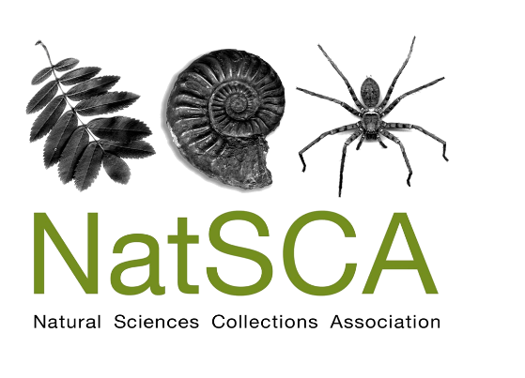
Membership form
NatSCA subscription year runs from 1st February to 31st January. To guarantee a hardcopy of the journal, please subscribe by 31st December.

Please return this form to: membership@natsca.org or Clare Brown at address below.

Institutional/Personal [please delete]

Name/contact name:

Institution:

Address for correspondence:

Email address:

Phone number:

Would you like to receive a hardcopy of the journal? Yes/No

Please select:
Personal membership: £20
Personal membership (unwaged): £15
Institutional membership: £40

PayPal
Please follow instructions for new members here: https://www.natsca.org/membership
If you are renewing your membership please contact membership@natsca.org for your renewal link.
BACS payments
Name or institute name must be quoted as reference and then remittance advice sent to membership@natsca.org please.
Bank – NatWest
Branch – Woking A Branch, 1 High Street, Woking, Surrey, GU21 6BG
Sort Code – 60-23-40
Account no. – 88387690
Account name – Natural Sciences Collections Association
IBAN GB51NWBK60234088387690
BIC NWBKGB2L
Cheques
Please make cheques payable to ‘Natural Sciences Collections Association’ and send to:
Clare Brown, Leeds Discovery Centre, Carlisle Road, Leeds, LS10 1LB

For any queries: membership@natsca.org
The data you provide will be used to contact you for the administration of your membership and sharing of information directly relevant to the role of NatSC. For our full GDPR statement please see http://www.natsca.org/privacy-policy . You can elect to have your name removed from the database but this will mean we are unable to mail you any information. Please inform us by contacting membership@natcsa.org if you wish to have your name removed from the database.

