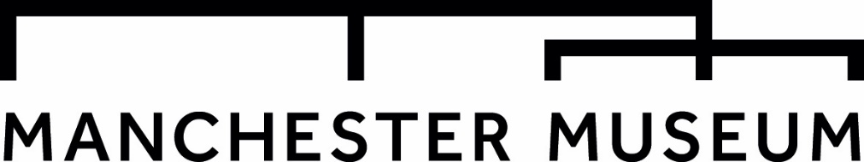
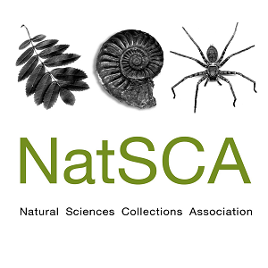

Making a Difference: Showing the Positive Impact of Natural History Collections
The Annual Conference & AGM of the Natural Sciences Collections Association will be held on Thursday 8th and Friday 9th May 2025 at The University of Manchester, Manchester Museum.
Natural history collections are involved in a huge range of work that has enormous positive impacts on people and the planet – this is a conference to share these stories. The #NatSCA2025 conference invites proposals for presentations looking at impact, how our work is making a difference, how we measure it, how we show success, and how we advocate for collections.
We seek ideas from the natural history collections community, educators, collaborators, and beyond. We are interested in practical lessons, unique solutions, new collaborations, and to show what has and hasn’t worked. We are particularly looking for presentations that share the differences museums are making in:
- facing global challenges such as the biodiversity and climate crises, and environmental issues
- improving people’s lives
- changing laws
- social justice, restitution, and decolonisation
We will prioritise papers that focus on sharing ideas, tools, and guidance rather than simply reporting results. We want to make this conference practical and useful, so please try to reflect this in your abstract.
While we have a focus on people that work with natural science collections, we recognise that we can learn from researchers and others in the wider museum sector. We welcome submissions from anyone who wishes to share techniques and ideas with broader relevance and application.
Papers can be presented as: A 20-minute presentation (consisting of a 15-minute talk followed by 5 minutes of Q&A), a 5 minute lightning talk, or a poster stand. Talks can be presented in person or by submission of a pre-recorded presentation, with the option of Q&A then being conducted over live video stream (Zoom).

Deadline for submission: 5pm GMT Friday 17th January
Please send the attached form to: conference@natsca.org
NatSCA Conference & AGM 2025
CALL FOR PAPERS

Name:
Organisation:
Contact details:
Social media (only add if you are willing for these details to be shared):
Presentation Format (select as appropriate):
20 Minute Presentation (In-Person / Pre-Recorded)
5 Minute Lighting Talk (In-Person / Pre-Recorded)
Poster Presentation (In-Person)
Title:
Abstract (200 - 300 words):

For in-person presentations, the conference fee for the day of your talk will be waived. You may claim travel and accommodation expenses of up to £150 following submission of a write-up of your paper to either the NatSCA Blog, the Journal of Natural Science Collections or NatSCA Notes & Comments, as appropriate. You must also present receipts to the Treasurer. Both the paper and the receipts must be submitted by 30th June 2025.
For co–delivered talks only one speaker is eligible for the free place at the conference and expenses reimbursement.

Deadline for abstracts is: 5pm GMT Friday 17th of January
Please send the attached form to: conference@natsca.org

